SAP PORTAL
- PROCUREMENT MODULE
Process Flow
[Sales] Customer Inquiry > [Sales] Customer PO > [Sales] Customer Order Form “COF”
Purchase Order > GRPO > AP Voucher > Check Voucher
Blanket Agreement:
Blanket Agreement > Purchase Order > GRPO > [See SAP PORTAL I.A.2.]

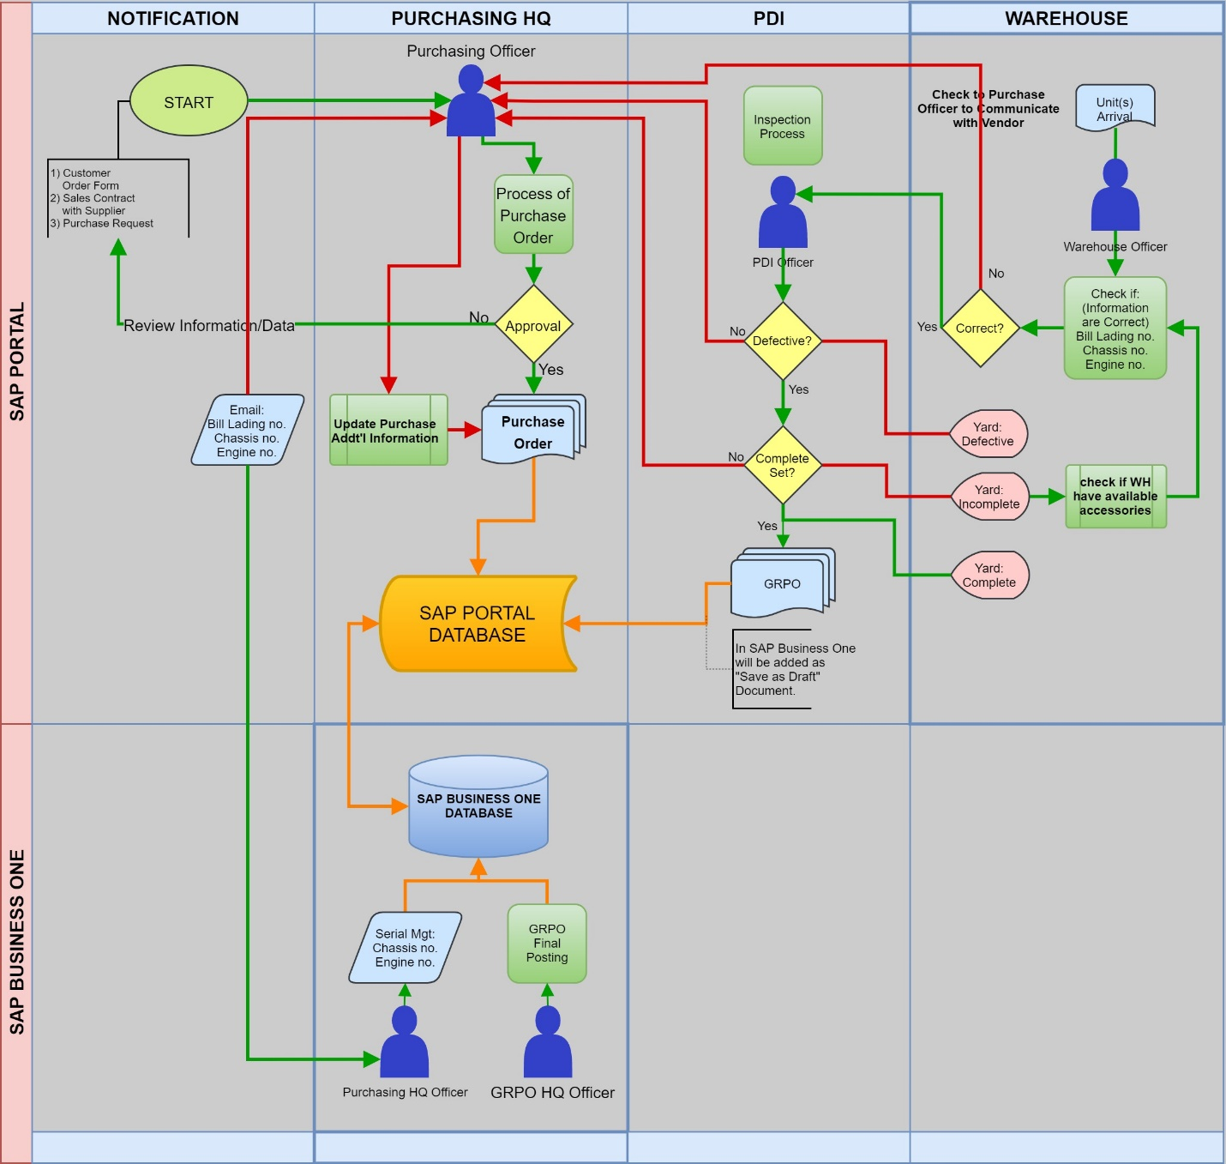

Purchase Order
- Issuance of PO will be based on availability of stock or based on the “Sales Contract Agreement” with Supplier.

There are Two (2) kinds of purchases:

Local

Importation

Confidential, for this transaction, Ms. Ria is only allowed to do this process.

Blanket Agreement
- These purchases are only applicable for Importation purchases.

Based on agreed Production to produce for a certain period.

90 days after arrival of Bill of Lading to pay billing.

Based on Funded or amount deposited to Supplier in import units.

Approval Process

Purchasing Manager: first to approve the document

General Manager – JLU: To finalize the approval document thru SAP Portal.

Handing over of PO

Send thru email in PDF File format

Cancelled PO Process

Cancelled PO will do an approval process.

Down payment from cancelled po will be transfer to new PO or another PO.

Change in Pricing or Quantity

Notification

Delivery Date used to Notify deliverables from Supplier, Mandatory to Input Delivery Date.

If item price for new created PO is different from previous added item need a prompt to notify user.

If created PO has the same item in open PO.

[Special Order Unit] If PO has been created will notify Salesperson via email.

Additional Information

PO series: [Internal Code] Initial – Date – #

User Define Field – Additional Field

Bill of Lading #

Supplier PO #

Chassis #

In-Transit [Yes/No]

Approved [Yes/No/Pending]

Mandatory Updates

Bill of Lading #

Delivery Date Update

Good Receipt PO
- Upon issuance of Purchase Order to the Supplier, waiting process for the arrival of Units.
- Bill of Lading # must be updated before receiving the units from the Import Supplier. Since Bill of Lading # are forwarded before the arrival of unit/spare parts in Warehouse.
- If unit are Good and Complete, it will be added in the portal. In SAP Business One, will be added as Save as Draft. HQ will do the final posting.

In-Transit [Report]

Once BL# information is update or have information, Unit/Item must show as in-transit status.

Search based on Item

Portal Users must see Item Status [In-Transit]

[Import Items] Broker does the forwarding of Unit/Item from Port to PowerTrac/FastPace Warehouse.

Aside from BL#, S/N (Chassis#, Engine#, etc.) are forwarded by supplier before the arrival of Units.

Must be recorded in SAP before the arrival of Item.

PDI [Quality Inspection before Receiving]

Yard [Warehouse/Bin]
- Create “Virtual” Yard for units/items that are for inspections or incomplete items

Virtual Warehouses:

PDI Yard 1-2-3

Incomplete/Missing Item Yard

Serial Management
- Unit are Set Item that has accessories to check to consider as Complete Unit received.
- Drop down list if Unit are Complete/Incomplete.

Additional Field [Drop List]

Unit Complete [Yes/No]

[If Incomplete] Accessories (Pre):

Side mirrors

Curtains

Head Light

Batteries

Toolbox

Others: (Specify) __________ (50 Character)

Defective [Yes/No]

Remarks (100 Character)

Serial Number
- Locking Serial Number if:
      - Unit have incomplete accessories
      - Defective
- Authorized user override to unlocked Serial Number:
      - HQ – Case basis.
      - PDI Manager – Accessories are complete.

UDO
- Add for Adding ChASSIS no and Engine
- UDF for Accessories
- Locked for Serial

Reports

- SALES MODULE
Process Flow
Sales Quotation > Customer PO > Customer Order Form > Opt.: Reservation > Dispatch > DR/SI > AR (Check) Payment

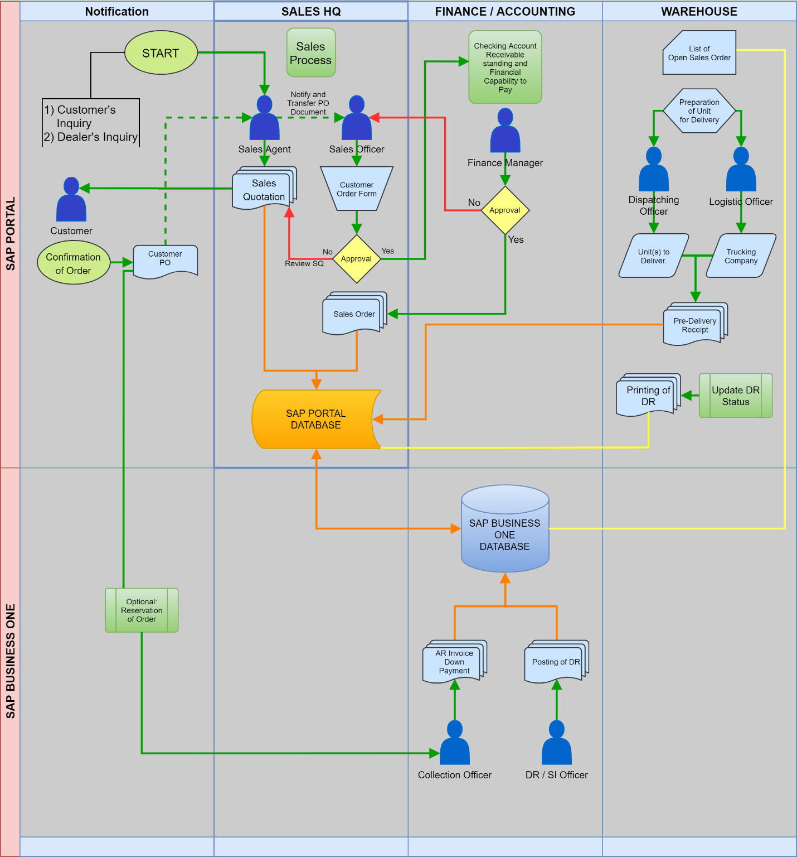

Sales Quotation

Customer Order Form [Manual Process]

Approval
- GM

Reservation [Optional]

Dispatching
- Dispatch must be based on Open SO and availability of Unit in Inventory
- If Unit is not available, SO will not be visible in SAP Portal
- Once Added in SAP Portal, it will be “Save as Draft” in SAP Business One

Ship Type

Pick up

Dilevery

Document Transaction must have two Tab

Units and Items to Delivery

Trucking Service or Company Information

Additional Fields [UDF]
- This in for are updated and reported from Dispatching in SAP Portal

Trucking Fee

Trucking Company

Travel: Sea, Land, and Sea/Land

Plate Number

Authorized Driver

Approval

PDI Head; and

Authorized Accounting Head

- INVENTORY MODULE

Inventory Viewing

Warehouse

Rename as Yard.
- Will create a Virtual Yard to classify items which are ready to Sell and incomplete unit.
- WH users may only view all items that are not yet receive.

Portal window

Make to Window for GRPO. Window 1, for Unit items. And Window 2, for Spare Part.

SAP Business One
- PROCUREMENT MODULE
Process Flow
[Sales] Customer Inquiry > [Sales] Customer PO > [Sales] Customer Order Form “COF”
Purchase Order > GRPO > AP Voucher > Check Voucher
Blanket Agreement:
Blanket Agreement > Purchase Order > GRPO > [See SAP PORTAL I.A.2.]

Goods Receipt PO

Save as Draft

Once added in SAP Portal, it will be added as “Save as Draft” in SAP Business One.

Users may view all “Save as Draft” in Document Draft Report to view the transaction and do the final posting of unit or spare part.

Importation Cost [Landed Cost]

Type of Importation Cost

Supplier Payment (Unit or Spare Part Cost)

Forwarder in China

Forwarder in Philippines

LTO

Direct Taxes

Additional Charger
- Reference information to Tag or Input for Payment purposes. Please see photo below.
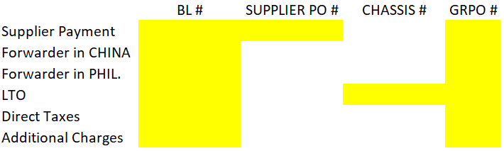

AP Voucher [AP Invoice]

Cash Advances

Broker

LTO Processor

Employees – Need to create Employee as Customer Business Master Data.

APV for Purchase Item (Import Unit)
- Cannot proceed if no GRPO transaction
- Down payments are done thru A/P Down Payment Invoice
- Full payments are process when Term Expires

- SALES MODULE

Sales Order
- Recording after done to Manually input from “Customer Order Form”

Dispatch [SAP Portal]

Delivery
- View in Document Draft Report, all “Save as Draft” Document from SAP Portal to SAP Business One.
- Final Posting will be done by HQ.

Additional Fields [UDF]
- This in for are updated and reported from Dispatching in SAP Portal

Trucking Fee

Trucking Company

Travel: Sea, Land, and Sea/Land

Plate Number

Authorized Driver

Location

Status DR Release: [Released/Not Released/Waiting(Default)]

In Waiting: [Date from:to]

If Released: [Date]
- To be update by Head Office

Received/Signed Date of DR: [Date]

Forms

Delivery Receipt

Delivery Note

Transmittal Form

Sales Invoice
- DR Status must be [Released]

Additional Fields
- Must be same as Delivery

- FINANCE

Collection
Process Flow
Preparation of Statement of Account > Counter Receipt > send to Client (via Email or Deliver) > Audit send Report > Collection Agent > Received Payment
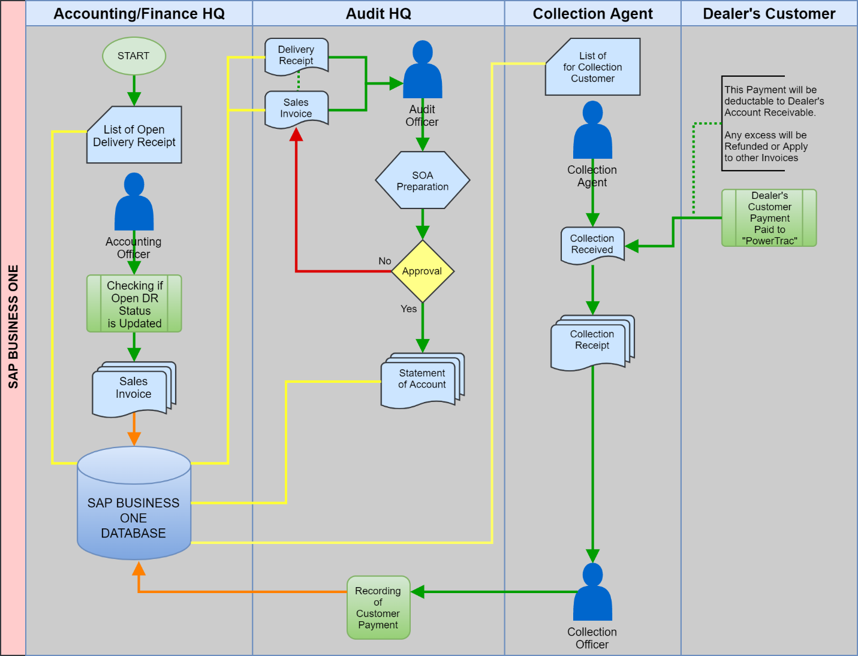

Statement of Account

Aging/Terms start in Date Release

Approval

Originator: Audit Officer

Approval: Audit Manager

Counter Receipt

Document attachment:
- Delivery Receipt
- Sales Invoice
- Statement of Account

Case Scenario to be Note:

Customer of Dealer sometimes pays direct to PowerTrac.
Recommendation:
- If upon payment of Customer exceeds the payment to be paid by Dealer, there will be an:
  - Off-Setting
  - Refund
- G/L Account once Exceed: Non-trade – Accounts Payable

PowerTrac and Fastpace, Vendor-Customer Relation
- Need to create Vendor MD and Customer MD

Bounce Check
- Cancellation of Incoming Payment if Customer will issue or advised to redeposit.

Return Checks

Mode of Payment
- Bank Online
- Check
- Cash

Rediscounting

Additional Field

OR#

Issued OR [Yes/No]

AR# (For DR issuance)

Disbursement
Process Flow
[Local]
Receive Billing Statement > Audit > Request for Payment > Approval > Check/Disbursement Voucher > Check/Bank Transfer > Approval > Release > Recording of Receipt
[Import]
Billing from Import Supplier > Authorized Person > Request for Payment > Approval > Check/Disbursement Voucher > Bank Transfer > Approval > Notification > Waiting Acknowledgement Receipt
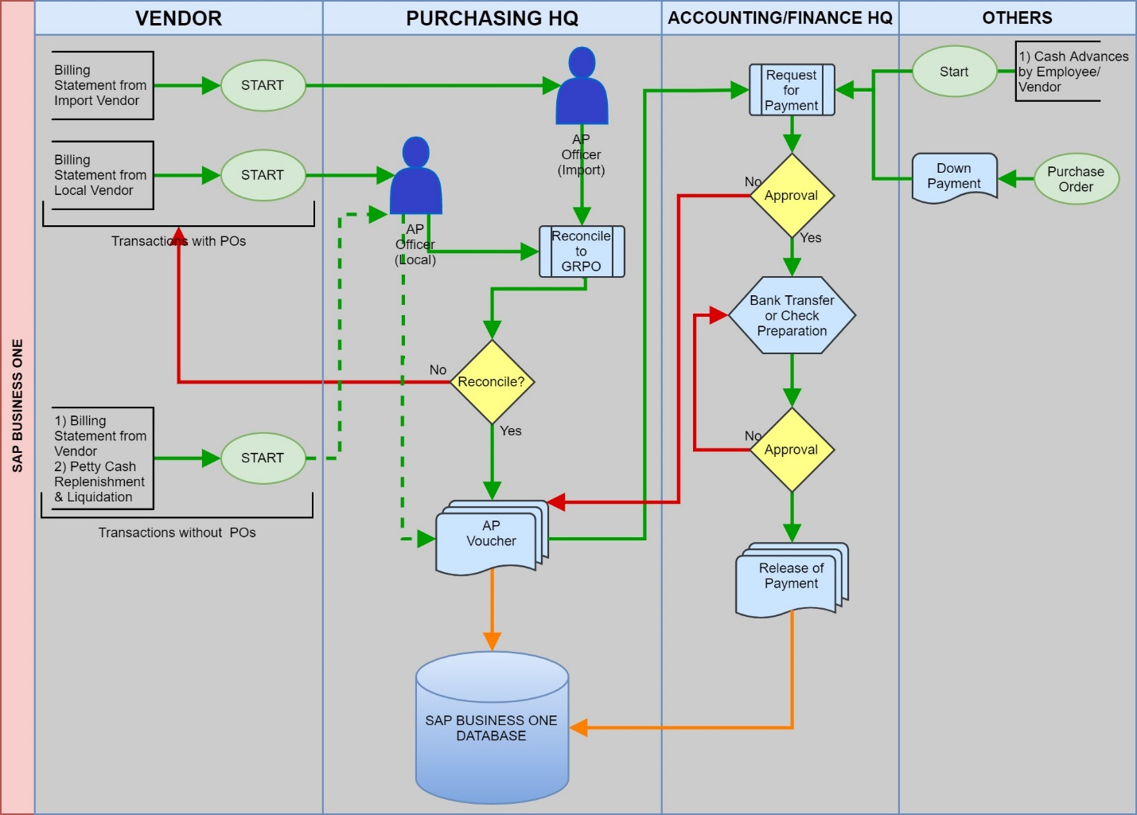

Cash Advance

Importation
- Broker
- LTO Processor

Employee
- Create Customer Business Master Data

Check/Disbursement Voucher

Information to Input
- Bank Information [Payment Means]
- Contact Number [UDF]
- If Different Payee
- Exchange Rate PHP to Currency of Supplier

Petty Cash Fund

If Use by P Voucher

Additional Field [UDF]
- Vendor Name
- Address
- TIN

Case scenario

If PCF used to Purchase Sale Item

[Request] Petty Cash Fund Module
- HQ – will have an direct access in recording of PCF Module
- Branches will retain to use Excel as Monitoring of PCF Expenses

Branches
- Service
- Davao
- Valenzuela
- Cebu

- INVENTORY MASTER DATA

Item Inventory

Inventory Group

Spare parts

Unit

Unit of Measurement

To be Send by Ms. Ria

Managed Item by:

Serial Number

Batch

Brand
- 1 Item Master Data per Brand

Warehouse

Rename as Yard.

Virtual Warehouse
- PDI Yard
- Dispatch Yard

Valuation Method
- Weighted Average

UoM
- To be send by Ms. Ria

Additional Field [User Defined Fields]

Serial Number Management or Batch Number Management

Additional Field
- Chassis Number
- Enginer Number
- Accessories [Yes/No]
  - Side mirrors
  - Curtains
  - Head Light
  - Batteries
  - Toolbox
  - Others: (Specify) __________ (50 Character)
- Locked
  - For Units that are incomplete.
  - If locked, cannot use to Dispatch and not available

- BUSINESS PARTNER MASTER DATA

Customer Master Data

Consolidation BP
- Consolidation Payment
- We will input Customers of PowerTrac/Fastpace Customer.
- Should have different Customer Code assign each Customer of PowerTrac/Fastpace Customer.

Dealer’s Customer:
- Need to Create Customer Dealers Master Data

Sister Companies
- Can view, Sister Company as Reference to check Financial Standing.

Vendor Master Data

- ACCOUNTING

Fixed Asset Inventory

Cost Center

To be send by Ms. Yul

Chart of Account

Reports

Financial Condition

Financial Operation

Statement of Cash Flow

BIR Reports

Bank Reconciliation

Bank Summary Report (For Replenishment)

Column(s)

Date

Check #

Payee

[UDF] Particular

G/L Account

Debit (Amount)

Credit (Amount)

Balance Forwarded

Commission Report

Series or Code

Sales Order

Delivery

Sales Invoice

Purchase Order

Goods Receipt PO

AP Voucher

Cash/Check Voucher

Inventory Out Slip (for Inventory Transfer or Good Issue)
- Code of Warehouse - #

Customer Master Data

Customer Code:

Dealer’s Customer Code: Customer Code - ####

Vendor Master Data

Inventory Master Data

Fixed Asset Master Data

